# Fall 2022 Data Science Intern Challenge

**Question 1: Please check below link for my answer**

[**https://github.com/pratibha6982/ShopifyChallenge2022/blob/main/ShopifyChallenge.ipynb**](https://github.com/pratibha6982/ShopifyChallenge2022/blob/main/ShopifyChallenge.ipynb)

**Question 2:** For this question you’ll need to use SQL. [Follow this link](https://www.w3schools.com/SQL/TRYSQL.ASP?FILENAME=TRYSQL_SELECT_ALL) to access the data set required for the challenge. Please use queries to answer the following questions. Paste your queries along with your final numerical answers below.

1. How many orders were shipped by Speedy Express in total?

**QUERY:**

SELECT

COUNT(DISTINCT o.OrderID) as TotalOrders

FROM

Orders o

INNER JOIN [Shippers] s using('ShipperID')

WHERE

ShipperName='Speedy Express'

**ANSWER: There are 54 orders that were shipped by Speedy Express**

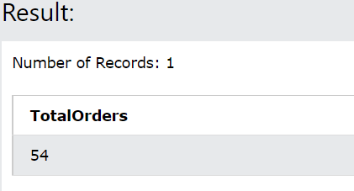

1. What is the last name of the employee with the most orders?

**QUERY**:

WITH temp_emp AS(

SELECT

EmployeeID,

COUNT(DISTINCT o.OrderID) as TotalOrders

FROM

[Orders] o

INNER JOIN [Employees] s using('EmployeeID')

GROUP BY

EmployeeID

ORDER BY

2 DESC

LIMIT 1

)

SELECT

LastName, TotalOrders

FROM

temp_emp

INNER JOIN Employees USING('EmployeeID')

**ANSWER: Last name of the employee is ‘Peacock’**

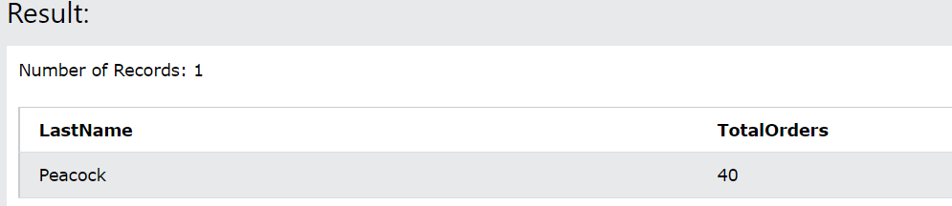

1. What product was ordered the most by customers in Germany?

**QUERY**:

WITH temp_maxProductOrder AS (

SELECT

ProductID,

SUM(od.Quantity) AS TotalOrdered

FROM

[Orders] o

INNER JOIN [OrderDetails] od USING('OrderID')

INNER JOIN [Customers] s USING('CustomerID')

WHERE

LOWER(Country)='germany'

GROUP BY

ProductID

ORDER BY

2 DESC

LIMIT

1

)

SELECT

ProductName,

TotalOrdered

FROM

temp_maxProductOrder

INNER JOIN [Products] USING ('ProductID')

**ANSWER: The Product ‘Boston Crab Meat’ was ordered the most by customer in Germany.**

